EOMMERCE WEBSITE WITH CHATBOT IMPLEMENTATION
A Project Report
Submitted in partial fulfilment of the
Requirements for the award of the Degree of
BACHELOR OF SCIENCE (INFORMATION TECHNOLOGY)
By
Bhakti Pravin More
And
Vedanti Vijay Uphale

Under the esteemed guidance of
Mr. Farhan Shaikh
Assistant Professor



DEPARTMENT OF INFORMATION TECHNOLOGY
M. L. DAHANUKAR COLLEGE OF COMMERCE
(Affiliated to University of Mumbai)
MUMBAI, 400057

MAHARASHTRA

ABSTRACT

Revolutionize your online shopping experience with our cutting-edge e-commerce platform, seamlessly integrating a user-friendly interface with a sophisticated chatbot. Explore a vast array of products effortlessly, while our intelligent chatbot stands ready to assist, providing personalized recommendations, answering queries, and enhancing your journey towards a streamlined and interactive online retail adventure.

ACKNOWLEDGEMENT

It is indeed with a great pleasure and immense sense of gratitude I acknowledge the help of our principal Dr. D.M. Doke for the facilities provided to accomplish this project. I am extremely thankful to our coordinator Smt. Archana Talekar for her constant support and inspiration in completing this project. The project could not be completed without the support of Mr. Farhan Shaikh. His support has been throughout the process and helped me clear even the smallest doubts related to documentation and helped me in the development of project by suggesting new features to be added that can improve my project. Finally, I express my sincere thanks to all the IT faculties, non-teaching staffs, and all my friends who directly or indirectly helped me in completion of project.

DECLARATION
I hereby declare that the project entitled, “Ecommerce Website With Chatbot Implementation” done at “M. L. DAHANUKAR COLLEGE OF COMMERCE”, has not been in any case duplicated to submit to any other university for the award of any degree. To the best of my knowledge other than me, no one has submitted to any other university.
The project is done in partial fulfilment of the requirements for the award of degree of BACHELOR OF SCIENCE (INFORMATION TECHNOLOGY) to be submitted as final semester project as part of our curriculum.

Bhakti Pravin More
&
Vedanti Vijay Uphale

TABLE OF CONTENTS
CHAPTER 1: INTRODUCTION 1
1.1 Background 1
1.2 Objectives 2
1.3Purpose, Scope and Applicability 3
1.3.1 Purpose 3
1.3.2 Scope 3
1.3.3 Applicability 4
1.4 Achievements 4
1.5 Organizational Report 5
CHAPTER 2: SURVEY OF TECHNOLOGY 6
2.1 Available Technology 6
2.2 List of Technologies 6
2.3 COMPARATIVE STUDY 9
2.4 Selected Technology 11
CHAPTER 3: REQUIREMENTS AND ANALYSIS 13
3.1 PROBLEM DEFINITION: 13
3.2 REQUIREMENT SPECIFICATION 14
3.2.1 Developers Requirements: 14
3.2.2 User Requirements: 14
3.3 PLANNING AND SCHEDULING: 14
3.3.1 Gantt Chart Representation: 14
3.3.2 Pert Chart: 16
3.4 Software and Hardware Requirements: 16
3.4.1 Software Requirements 16
3.4.2 Hardware Requirements 17
3.5 PRELIMINARY PRODUCT DESCRIPTION: 17
3.6 CONCEPTUAL MODELS 17
CHAPTER 4: SYSTEM DESIGN 26
4.1Basic Modules 26
4.2 Data Design 27
4.2.1 Schema Design: 27
4.2.2 Database Integrity and Constraints 27
4.3 PROCEDURAL DESIGN: 30
4.3.1 LOGIC DIAGRAM: 31
4.3.2 DATA STRUCTURES 32
4.3.3 ALGORITHMS DESIGN: 33
4.4 USER INTERFACE DESIGN 34
4.5 SECURITY ISSUES 38
4.5 TEST CASES DESIGN 39

LIST OF TABLES
Table 1:2.3.1 Comparative Study 10
Table 2:3.6.1 Use Case Diagram 18
Table 3:3.6.2ER Diagram 19
Table 4:3.6.3Activity Diagram 22
Table 5:3.6.4 Data Flow Diagram 23
Table 6:4.2.2.1 User Login 26
Table 7:4.2.2.2 Admin Login 27
Table 8:4.2.2.3 Product 27
Table 9:4.2.2.4 Customer 27
Table 10:4.2.2.5 Vendor 28
Table 11:4.2.2.6 Invoice 28
Table 12:4.2.2.7 Stock 28
Table 13:4.2.2.8 Chatbot 29
Table 14:4.2.2.9 Payment 29
Table 15:4.5.1 Admin login 38
Table 16:4.5.2 SignUp 38
Table 17:4.5.3 User Login 39

LIST OF FIGURES
Figure 1:3.3.1.1 Gantt Chart 15
Figure 2:3.3.2 Pert Chart 16
Figure 3:3.6.1 Use Case diagram 19
Figure 4:3.6.2 ER diagram 20
Figure 5:3.6.3 Activity diagram 23
Figure 6:3.6.4 Data Flow Diagram 25
Figure 7:4.3.1.1 Logic diagram 31
Figure 8:4.4.1 Sign-in Page 34
Figure 9:4.4.2 Signup Page 35
Figure 10:4.4.3 Home Page 36
Figure 11:4.4.4 Chatbot 37

CHAPTER 1: INTRODUCTION

Background

In our Ecommerce website where convenience and personalized assistance come together seamlessly. With the power of Artificial Intelligence, our Chabot is designed to be your reliable virtual shopping assistance. Whether you are browsing for products, seeking recommendations, or need assistance with any step of the purchasing process, our Chabot is here to provide real-time support and enhance your overall shopping experience.
We believe that communication is key, and our Chabot is trained to understand user’s queries and provide accurate responses. No more scrolling through pages of FAQ’s or waiting on hold for customer service representatives. Our Chabot is available 24/7, ready to address your queries and prompt you solutions, allowing you to shop on your convenience.
But our Chabot is not just about customer service; it's also a valuable companion in helping you discover products that align with your preferences and interests. By leveraging advanced algorithms, it learns from your interactions, understands your preferences, and suggests personalized recommendations tailored to your taste. With our Chabot, you'll never miss out on finding that perfect item again.
We have implemented the Chabot so that you can sit back, relax, and let our Chabot take the reins, guiding you through our vast selection of high-quality products and helping you make the best choices that suit your needs.
At our ecommerce website, we understand the future of online shopping. We have harnessed the power of machine learning algorithms to train our Chabot in understanding natural language and providing accurate and contextually relevant responses to customer queries. Our Chabot acts as a virtual shopping assistant, available 24/7 to guide customers through their purchasing journey. It understands the importance of timely and accurate information, and is equipped to handle a wide range of inquiries, from product recommendations and order tracking to payment assistance and returns processing.
We have taken great care to ensure that our Chabot integrates seamlessly into our ecommerce website, providing a smooth and intuitive user interface. Customers can interact with the Chabot through a chat window, easily accessible from any page of our website. This ensures that support is always just a click away.

1.2 Objectives

- The primary objective of implementing a Chabot is to improve customer support and provide timely assistance.

- Chabot aims to deliver a personalized shopping experience by understanding customer preferences and providing tailored recommendations. By analyzing customer interactions and purchase history

- Chabot will guide customers through various stages, such as product selection, adding items to the cart, and completing the checkout process. It can assist with order tracking, address any payment-related queries, and provide shipping details.

- Implementing a chatbot can help reduce customer service costs by automating repetitive tasks and frequently asked questions.

- By Improving Conversion Rates it will provide personalized recommendations, real-time support, and a seamless shopping experience, our objective is to increase conversion rates.

- The chatbot aims to build customer trust, minimize hesitation during the purchase process, and address any concerns promptly.

- The main objective is to save time and efforts of customers.

- One to one conversation between user and chatbot.

1.3Purpose, Scope and Applicability

1.3.1 Purpose
The purpose of developing an e-commerce website with chatbot depends upon specific goals and objectives such as:
- Improve customer support:
It will provide an assistant who will address their queries instantly. This will improve the customer satisfaction as well as the satisfaction level is high when the reply is quick.
- Enhance user experience:
By using (NLP) and machine learning chatbot can engaged in personalized and tailored recommendations and guiding them throughout shopping purpose
- Customer support capabilities:
As an e-commerce business grows, handling customer support requests manually can become overwhelming. It also requires more man power, so it’s also effecting the company payouts. A chatbot can handle a large volume of inquiries simultaneously 24/7.
- Automate order tracking:
A chatbot will track order on Shipping status and order history so it reduces the need for customer to contact support for basic queries.
Overall, the purpose to implement a chatbot in e-commerce website is to streamline customer experience by providing them personalized automated assistant.

1.3.2 Scope

The scope of an ecommerce website with Chabot implementation is to provide an enhanced and seamless shopping experience for customers. The integration of a Chabot serves multiple purposes.
- Customer Assistance: The Chabot acts as a virtual shopping assistant, providing real-time support to customers. It can answer inquiries, offer product recommendations, assist with the ordering process, provide order status updates, and address common concerns. the purpose is to ensure that the customer has a smooth and enjoyable shopping experience.
- Personalization: The Chabot can deliver personalized recommendations and tailored experiences. It understands customer preferences, purchase history, and browsing behavior to suggest products according to their interests.
- 24/7 Availability: The customer service channels have limited operating hours, but the Chabot is available 24/7. It ensures that customers can get support and information whenever they need. The purpose is to offer convenience and instant assistance, enhancing customer satisfaction and loyalty.
- Cost efficiency: Implementing a Chabot helps streamline customer support and reduce costs. The Chabot can handle a significant volume of inquiries, automating repetitive tasks and frequently asked questions. The purpose is to optimize operational efficiency and reduce customer service costs.
- Conversion Optimization: By providing personalized recommendations, addressing customer concerns, and simplifying the purchase process, the Chabot aims to improve conversion rates. It helps build customer trust, reduces friction during the buying journey, and encourages customers to complete their purchases.

1.3.3 Applicability
The project will help the customer to save time and efforts with the help of Chabot they can have one to one communication so that they do not have to wait for the customer service to response so the response time becomes fast. The customer can have their virtual assistance to help them throughout the shopping process.

1.4 Achievements
- Improved user experience:
Implementing the chatbot has increase user interaction and hence results into satisfied and happier customer.
- 24/7 support:
Customer would get help at anytime they need. Thus it will save time
- Efficient cart management:
User would be able to manage the shopping cart with the help of chatbot.
- Competitive advantage:
By efficiency and innovation of the chatbot it set us apart from the market.
- Lighter support load:
The chatbot will address the common queries so that it will reduce the workload of support system.

1.5 Organizational Report
Chapter 2: In accordance with immense number of technologies available we have selected a list of technology for the project and that has been discussed in this chapter.
Chapter 3: The analysis and planning of the project have been describe over here including both software and hardware requirements. The product description that how the product would perform have been explained with the help of conceptual models that includes use case diagram, ER diagram, activity diagram and data flow diagram is been discussed in this chapter.
Chapter 4: This chapter includes the basic data modules and how the user's data have been stored in the database and the overall flow of the product have been explained with the help of logic diagram and different data structures is being discussed and it also includes user interface like how the user will interact. And the security issues that again plays an vital role in the project.
Chapter 5: This chapter emphasize on various testing strategies and upholding the product quality along with the project's execution and overall, how the product will perform with various test cases.
Chapter 6: The test cases that has been outlined in the above chapter would be put in this chapter and the behaviour of the product would be documented.it will examine whether the outcome is correct in accordance with the expected result.
Chapter 7: Reference.

CHAPTER 2: SURVEY OF TECHNOLOGY

2.1 Available Technology

The existing website includes chatbot facility that will solve the user's query and will reduce user's work.
As chatbot is an AI tool which is grabbing people's attention as it simulates human conversation through text or voice interactions.
It also allows you to train your chatbots by uploading a list of conversations and text messages.
There are many programming languages available but for these websites we are using Python as a frontend which is a popular language for web and software development.
SQL(Structured query language) as a backend. It's a specialized language for managing relational database which allows to store, insert, update, and delete the data in a structured manner.

2.2 List of Technologies



- HTML: HTML stands for Hypertext Markup Language. It is used to create web pages and web applications.HTML is widely used language on the web. We can create static website by using HTML only.


- CSS: CSS stands for Cascading Style Sheets.CSS language is use to style HTML documents. CSS describes the presentation of web pages, including colors, layout, and fonts.


- PYTHON: Python is a programming language that enables you to work rapidly and integrate systems more effectively. Python is dynamically typed and garbage-collected. It supports multiple programming paradigms, including procedural, object-oriented, and functional programming. Python is often described as a "batteries included" language due to its comprehensive standard library.


- JAVA: Java is widely used object-oriented programming language and software platform that runs on billons of device including notebook computers, mobile device, gaming consoles, medical devices, and many others.The rules and syntax of java are based on the C and C++ languages.


- JAVASCRIPT: JavaScript is a programming language commonly used in web development. JavaScript is easy to learn and also a powerful scripting language widely used for controlling web page behaviour.


- MySQL: MySQL is a relational database management system based on the Structured Query Language, which is the popular language of accessing and managing the records in the database

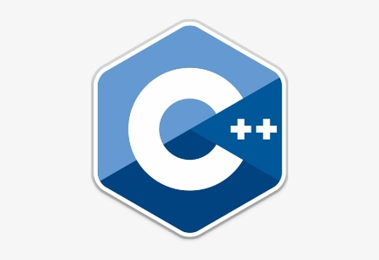
- C++: C++ is an object-oriented language known to be one of the difficult languages to learn but it is an important language for game developers. It also gives a lot of control over parameters and memory management, adding to the performance and user experience of the game.


- PHP: PHP is a server-side scripting language that is embedded in HTML. It is used to manage dynamic content, database, session tracking, and build entire e-commerce sites. Using PHP, you can restrict users to access some pages of your website.


- C#: C# is popularly used in many game engines today and is one of the most popular languages required for game development. It has an XNA framework, which is a set of tools and runtime environment by Microsoft, which makes it particularly suitable for games on the Xbox or windows. It is a good language if one wishes to use monogame to distribute the game on virtually any platform.

- KOTLIN: Kotlin, officially supported for Android app development, is a versatile language compatible with Java. With its concise syntax and enhanced safety features, it has gained traction among Android developers worldwide.

2.3 COMPARATIVE STUDY

Technology | Features | Advantages | Disadvantages
PYTHON | - Object Oriented  - Easy to Code  - Easy to Read  - Robust Standard Library  - Portable Extensible | - Improved Productivity  - Interpreted Language  - Dynamically Typed | - Slow Speed  - Not Memory Efficient  - Weak in Mobile Computing  - Database Access  Runtime Errors
JAVA | - Object Oriented  - Platform Independent  - Architecture-neutral  - Portable Java is easy to learn | - Simple  - Secured  - Multi-Threaded Robust | - Performance  - Memory consumption  - Cost  Less machine interactive
JAVASCRIPT | - Scripting Language  - Interpreter Based  - Event Handling  - Light Weight  - Case Sensitive  Control Statements | - High interoperability  - Enhanced speed  Performance  - Shorter codes  - Extended Functionality | - Debugging  facilities need  improvement.  - Client-side  Security.  - Browser Support.  - Lack of Debugging  Facility  - Single Inheritance.
MySQL | - Query Language  - Character Sets  - Quick & Reliable  - Client / Server  Architecture Flexible | - Multi-userer  support  - Support large  Database  - Data Security Scalable | - Less Efficient  - Poor  Performance in High Load
PHP | - Performance  - Familiarity  - Open Source Platform independent | - Free cost  - Extremely  Flexible User Friendly | - Security Issue  - Not Secure  - Poor error handling method
C# | - Boolean Condition  - Automatic garbage  Collection Assembly Versioning | - Portability  - Concept of oops  - Automatic  Garbage collection | - Less flexible  - Low level  concurrency  - Poor cross platform UI
Kotlin | - Functional and object  Oriented Modern Features | - Highly  compatible  - Simple syntax  - Excellence tooling support | - Small Community  - Limited resources for learning
HTML | - User friendly  - Semantic structure Flexible | - Browser  friendly  - Static language Free to use | - Limited security Dependency issue
CSS | - Flexibility Very small size | - Enhance user  experience  - Consistency  - Time-efficient  - Improves speed  - Easy Maintenance | - Security issues  - Creates confusion  - Cross-browser  issues
Table 1:2.3.1 Comparative Study

2.4 Selected Technology

List of Selected Technologies :
- PYTHON
- HTML
- CSS
- MySQL

- Selected Technologies & Why?

- PYTHON :
Python is a high-level, interpreted, and dynamically-typed programming language known for its simplicity, readability, and versatility. It was created by Guido van Rossum and first released in 1991. Python has gained widespread popularity in various fields, including web development, data science, artificial intelligence, scientific computing, and more, due to its rich ecosystem of libraries and frameworks.

- HTML :
HTML allows users to create and structure sections, headings, links, paragraphs, and more, on a website using various tags and elements. Almost everything you want to create on a web page can be done using a specific HTML code.

Some Features Of HTML:
I. Platform Independent.
II. Multiple Web Pages can be linked to each other.
III. Simple & Readable.

- CSS :
CSS is a stylesheet language used to describe the presentation of a document written in HTML. It is generally used with HTML to change the style of web pages and user interfaces. It is easier to make web pages presentable using CSS. CSS helps to control the text color, font style, layout designs, and many more.

Some Features Of CSS:
I. Greater Accessibility.
II. Lightweight Code.
III. Greater Consistency in design.

- MySQL :
MySQL can be freely used without incurring the cost of a commercial database platform. MySQL determines the speed of when things load on your site and how fast you can access that stored data.

Some Features Of CSS:
I. Solid Data Security.
II. Fast Speed.
III. Easy to Use.

CHAPTER 3: REQUIREMENTS AND ANALYSIS

3.1 PROBLEM DEFINITION:

In today's digital landscape, e-commerce has become an integral part of retail, offering customers the convenience of shopping from the comfort of their homes. However, online shopping can sometimes lack the personalized assistance and guidance that customers receive in physical stores. To address this gap, the integration of a chatbot within the e-commerce website can provide real-time assistance, answer queries, and guide users through their shopping journey.
The Project aims to create a user -friendly Ecommerce platform that incorporate a sophisticated chatbot capable of understanding customer inquiries, offering and product recommendations, revolving issues, and guiding users through the purchasing process.
Developing an ecommerce website with integrated chatbot functionality aims to bridge the gap between online and window-shopping experiences. By creating an interactive website for users aims to enhance customer engagement, satisfaction and ultimately contribute the success of the ecommerce business.
- Solution to the above problem would be:
Enhancing the chatbot’s Natural Language understanding (NLU). By clearly communicate to users the limitations of the chatbot and offer alternative ways to reach human agents to inquiries.
Implementing a hybrid model where the chatbot handles routine inquiries, but seamlessly hands off more complex or personalized interactions to human customer support agent.
Building the chatbot’s language capabilities by supporting multiple languages. Monitoring user interaction to ensure the chatbot understands and responds accurately to various linguistics.

3.2 REQUIREMENT SPECIFICATION

3.2.1 Developers Requirements:
- Laptop.
- Wi-Fi-Router.
- Electricity

3.2.2 User Requirements:
- Smartphones
- Internet Connection
- Bank Account (if online Payment)

3.3 PLANNING AND SCHEDULING:

3.3.1 Gantt Chart Representation:
A Gantt chart is crucial for the Anonymous Group Chat for Student project as it visually outlines tasks, timelines, and dependencies. It aids in planning tasks, managing dependencies, tracking progress, and allocating resources efficiently. This promotes clear communication, minimizes delays, and ensures the project stays on schedule, enhancing successful execution. 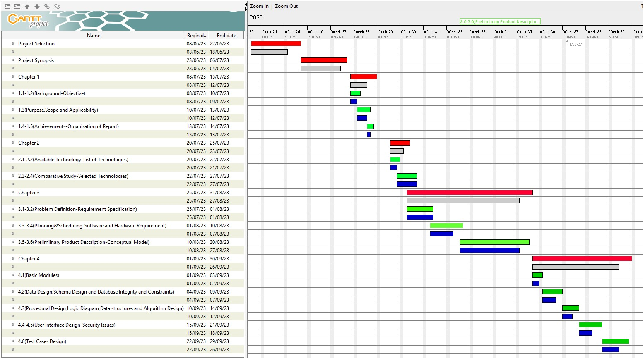
Figure 1:3.3.1.1 Gantt Chart

3.3.2 Pert Chart:
In the context of the Anonymous Group Chat for Student project, a PERT (Program Evaluation and Review Technique) chart is essential. It helps break down tasks, identify dependencies, and estimate timeframes, ensuring efficient coordination and resource allocation. This visual tool enhances team collaboration, communication, and overall project management, leading to a successful development of the student chat platform.

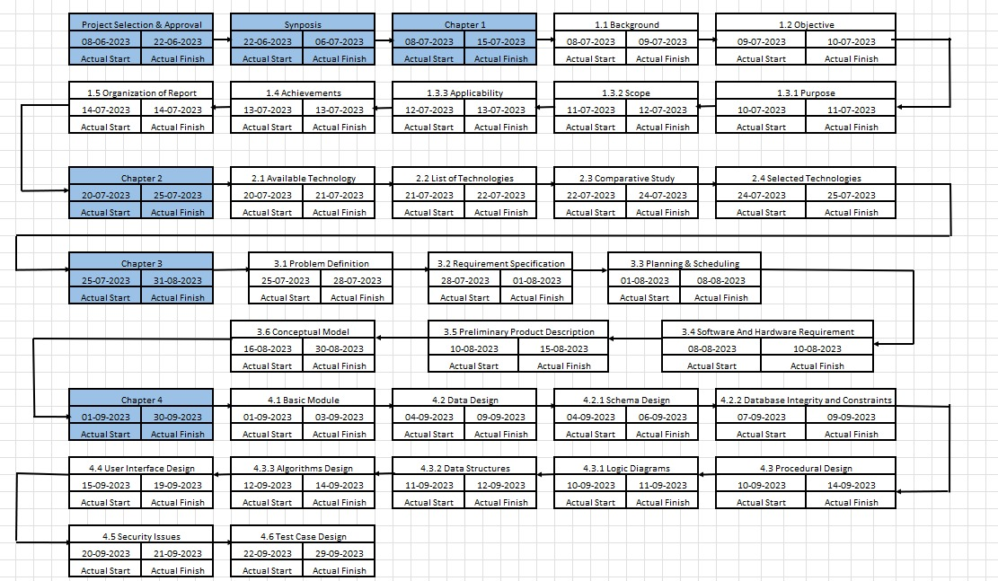

Figure 2:3.3.1.2 Pert Chart

Figure 2:3.3.2 Pert Chart

3.4 Software and Hardware Requirements:

3.4.1 Software Requirements

- Operating System-Windows 7 or above.

- Programming Language- Python, Java.

- Database- MYSQL

- Frontend-HTML, CSS.

3.4.2 Hardware Requirements

- Personal Computer.

- Processor intel core i5.

- Installed memory RAM 8.00GB.

3.5 PRELIMINARY PRODUCT DESCRIPTION:

Introducing our cutting-edge eCommerce website, where shopping meets seamless interaction. Our platform combines the convenience of online shopping with the personal touch of a chatbot assistant. Explore an extensive range of products from various categories, all easily accessible through our user-friendly interface. But that's not all – our intelligent chatbot is here to assist you 24/7. From product recommendations to order tracking, it's like having your own shopping guide at your fingertips. Experience the future of shopping with our eCommerce website and revolutionize the way you shop online.

3.6 CONCEPTUAL MODELS

- Use Case Diagram:
A use case is a textual or visual representation that describes how a system or software application interacts with various actors (users or external systems) to achieve specific goals. It outlines the steps or interactions that occur between the actors and the system to complete a specific task or process. Use cases are widely used in software development and systems analysis to define and communicate functional requirements and user interactions.

Component Name | Symbol | Description
Actor/User |  | An actor specifies a role played by a user or any other system that object.
Use Cases |  | Represent the different  uses that a user might  have.
Association |  | A line between actors and  use cases.
System Boundary | 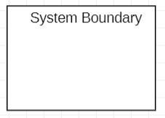 | It separates the internal components (use cases) from external actors, showing what's within the system and what's outside.
Include | 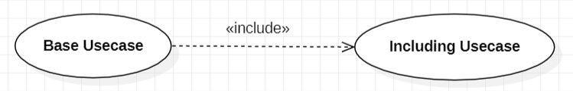 | Include shows that one use case (the base) includes another use case (the included) as a part of its normal flow. It's like a subroutine call, where the included use case is essential for the main use case to function correctly.
Extend | 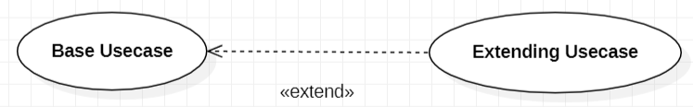 | Extend signifies optional, conditional behaviour. An extending use case adds extra steps to the base use case under certain conditions.
Table 2:3.6.1 Use Case Diagram

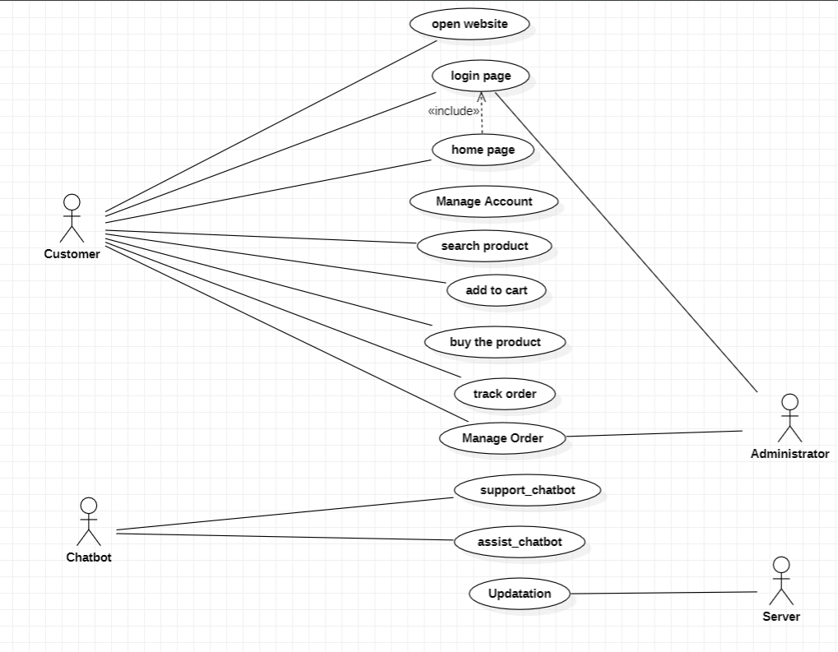

Figure 3:3.6.1 Use Case diagram

- ER diagram:
Entity relationship diagram (ERD) also known as entity relationship model, is a graphical representation that depicts relationships among people, objects, places, concepts or events within an information technology system.

Component Name | Symbol | Description
Entities | 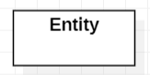 | Represented as a rectangle, an entity represents a real-world object, concept, or thing. For example, “Student” could be an entity.
One to One Relationship |  | This relationship signifies that each instance of one entity is uniquely related to only one instance of another entity. It implies a direct and singular connection between the two entities.
One to Many Relationship |  | This relationship represents a scenario where one entity instance is associated with multiple instances of another entity, but each instance of the second entity is linked to only one instance of the first entity.
Many to Many Relationship |  | In this type, multiple instances of both entities are connected, indicating that each instance from one entity can be associated with multiple instances from the other entity, forming a complex network.
Table 3:3.6.2ER Diagram

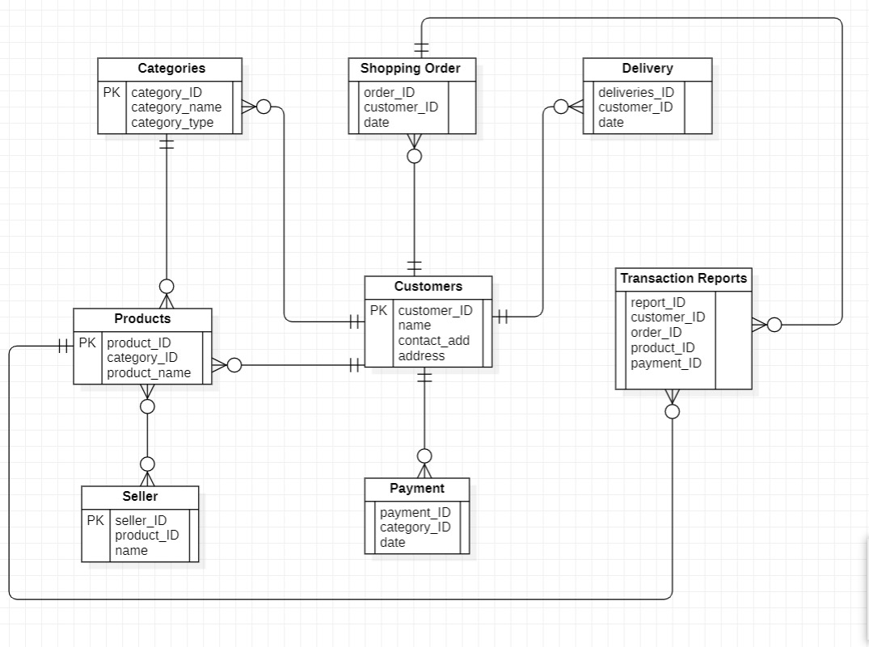
Figure 4:3.6.2 ER diagram

- Activity diagram:
Activity diagram is another important behavioural diagram in UML diagram to describe dynamic aspects of the system. Activity diagram is essentially an advanced version of flow chart that modelling the flow from one activity to another activity.
Activity Diagrams describe how activities are coordinated to provide a service which can be at different levels of abstraction.

Component Name | Symbol | Description
Initial State |  | A small filled circle followed by an arrow represents the initial  action state or the start point for any activity diagram.
Activity or Action State | 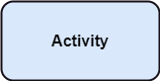 | A step in which the users or software performs a certain task. It represents an action that is going to take place at this stage of the software system.
Decision and Branching | 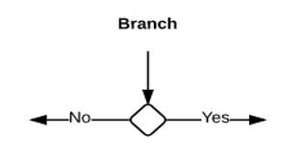 | A decisional node is one where there are multiple options available. Or there are two or more conditions which can be considered at the point of the software system.
Merge Node | 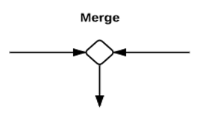 | The notation for a merge node is a diamond-shaped symbol with  two or more edges entering it and a single activity edge leaving it. Merge node and decision node combined. The functionality of merge node and decision node can be combined by using the same node symbol.
Fork node | 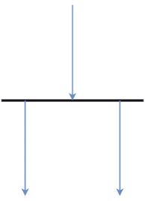 | A point from where two concurrent or parallel processes are executed or run, or processed. It generally includes a single input but may or may not get one output.
Join Node |  | Join node is a control node that has multiple incoming edges and  one outgoing edge and is used to synchronize incoming concurrent flows. Join nodes are introduced to support parallelism in activities.
Final state |  | An arrow pointing to a filled circle nested in another circle  represents the final action state.

Table 4:3.6.3Activity Diagram

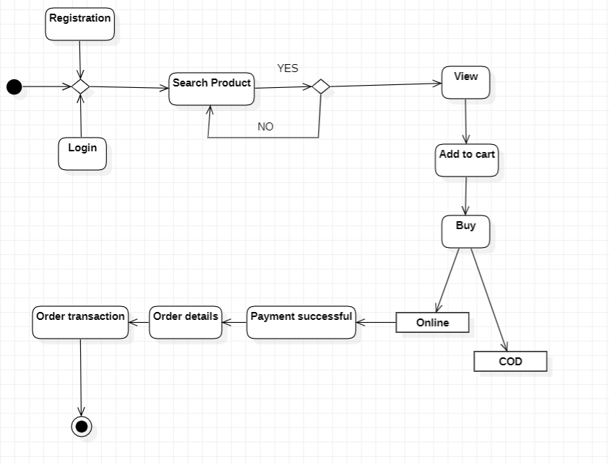
Figure 5:3.6.3 Activity diagram

- Data Flow Diagram:
A data flow diagram is a visual representation of a process or system's data flow. The data flow diagram also details the inputs and outputs of every entity involved in the operation. There are no loops, decisions, or control flows in a data flow diagram.

Component Name | Symbol | Description
Process | 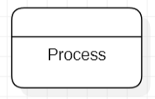 | Processes represent activities or functions that transform input data into output data. They are the actions performed on data within the system.
Data Source | 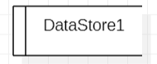 | Data Stores represent repositories where data is stored. They can be databases, files, or any other storage location. Data flows in and out of these stores through processes.
External Entity | 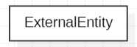 | External Entities are sources or destinations of data that interact with the system but are outside of it. They represent users, other systems, or external data sources.
Data Flow |  | Data Flows depict the movement of data between processes, data stores, and external entities. They indicate how data is transferred, processed, or stored within the system.
Table 5:3.6.4 Data Flow Diagram

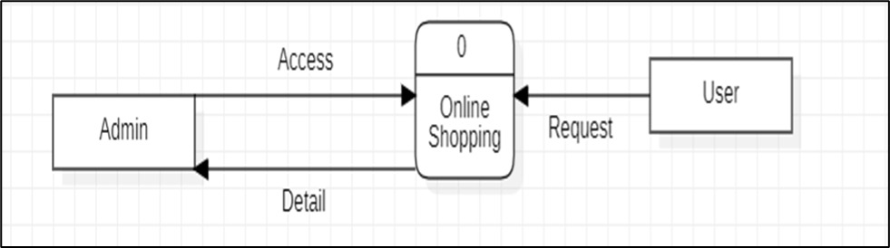

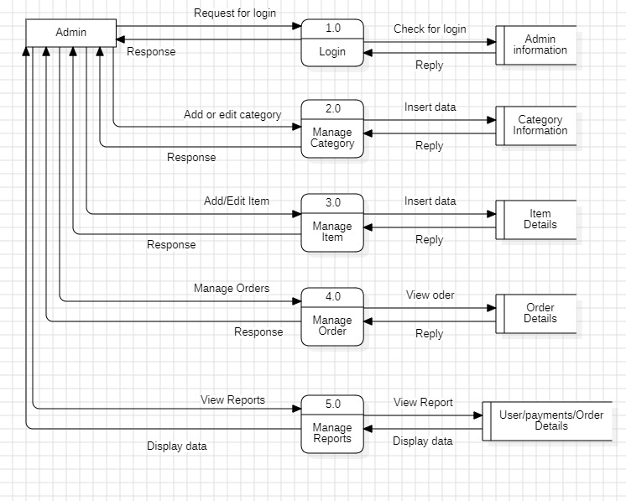

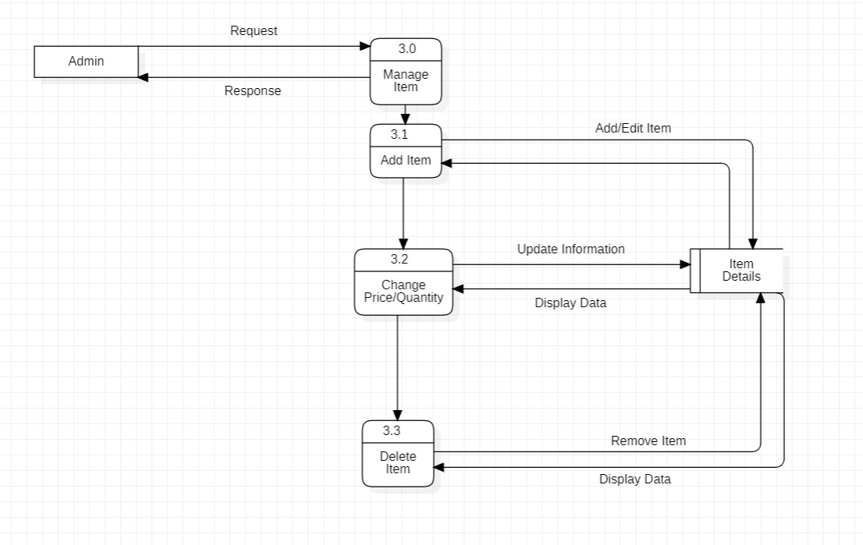

Figure 6:3.6.4 Data Flow Diagram

CHAPTER 4: SYSTEM DESIGN

4.1Basic Modules
User Registration:
- Allows user to create an account and to implement a secured login system.
Product CatLog:
- The product database will store the information of the product like the description about a particular product. And the product filtering will allow the user to filter the results.
- Allow users to add the items in the cart that they can be able to view and modify later and to implement a safe and secure checkout process.
Order History:
- It shows the users their order history and status. Sends the email once their order is being confirmed.
- Users are also able to track their orders.
Chatbot Integration:
- Chatbot is implemented for users to interact with the system.
- Allow users to inquire about their orders, track shipments, or request returns through the chatbot.
User profile:
- Allow users to manage their personal information, shipping addresses, and payment methods.
- Let users leave reviews and ratings for products.
Email Notifications:
- The Chatbot will send the notification to the user regarding the new updates, discounts, and recommendations.
Database module:
- It stores the user information, product information, Chat history with Chatbot.

4.2 Data Design

4.2.1 Schema Design:
Schema design organizes data into separate entities, determines how to create relationships between organized entities, and influences the applications of constraints on data. Designers create database schemas to give other database users, such as programmers and analysts, a logical understanding of data.
- Database name
Ecom_db

- List Of Tables

- Tb_Admin
- Admin Login
- User Login
- Vendor Detail
- Product Detail
- Company Detail
- Tb_Chatbot
- Invoice Detail

4.2.2 Database Integrity and Constraints
- Database name
Ecom_db

- Database Tables
- User Login:

Field | Type | Null | Key | Default | Extra
F_Name | Varchar(40) | No |  | NULL
L_Name | Varchar(40) | No |  | NULL
Username | Varchar(40) | No | Primary Key | NULL
Password | Varchar(40) | No |  | NULL
Email | Varchar(40) | No |  | NULL

Table 6:4.2.2.1 User Login

II. Admin Login:

Field | Type | Null | Key | Default | Extra
Admin_ID | Varchar(40) | No | Primary Key | NULL
F_Name | Varchar(40) | No |  | NULL
L_Name | Varchar(40) | No |  | NULL
Username | Varchar(40) | No |  | NULL
Password | Varchar(40) | No |  | NULL
Phone | Int(20) | No |  | NULL
Email | Varchar(40) | No |  | NULL
Table 7:4.2.2.2 Admin Login

III. Product:
Field | Type | Null | Key | Default | Extra
Product_ID | Varchar(40) | No | Primary Key | NULL | Auto Increment
P_Name | Varchar(40) | No |  | NULL
Description | Varchar(40) | No |  | NULL
Category_ID | Varchar(40) | No | Foreign Key | NULL
Supplier_ID | Varchar(40) | No | Foreign Key | NULL
Stock_Quantity | Int(20) | No |  | NULL
Unit_Price | Int(20) | No |  | NULL
Table 8:4.2.2.3 Product
IV. Customer :
Field | Type | Null | Key | Default | Extra
Customer_ID | Varchar(40) | No | Primary Key | NULL | Auto Increment
F_Name | Varchar(40) | No |  | NULL
L_Name | Varchar(40) | No |  | NULL
Email | Varchar(40) | No |  | NULL
Phone | Int(20) | No |  | NULL
Address | Varchar(40) | No |  | NULL
Table 9:4.2.2.4 Customer

V. Vendor:

Field | Type | Null | Key | Default | Extra
Vendor_ID | Varchar(40) | No | Primary Key | NULL | Auto Increment
Company_Name | Varchar(40) | No |  | NULL
V_Name | Varchar(40) | No |  | NULL
Email | Varchar(40) | No |  | NULL
Address | Varchar(40) | No |  | NULL
Phone | Int(20) | No |  | NULL

Table 10:4.2.2.5 Vendor

VI. Invoice:
Field | Type | Null | Key | Default | Extra
Invoice_ID | Varchar(40) | No | Primary Key | NULL | Auto Increment
Customer_ID | Varchar(40) | No | Foreign Key | NULL
Invoice_Date | Int | No |  | NULL
Invoice_End | Int | No |  | NULL
Total_Amount | Int | No |  | NULL
Table 11:4.2.2.6 Invoice

VII. Stock:
Field | Type | Null | Key | Default | Extra
Stock_ID | Varchar(40) | No | Primary Key | NULL | Auto Increment
Product_ID | Varchar(40) | No | Foreign Key | NULL
Quantity | Int | No |  | NULL
Location | Varchar(40) | No |  | NULL
Table 12:4.2.2.7 Stock
VIII. Chatbot:
Field | Type | Null | Key | Default | Extra
User_ID | Varchar(20) | No | Primary Key | NULL | Auto Increment
Username | Varchar(20) | No |  | NULL
Message_ID | Varchar(20) | No |  | NULL
Timestamp | Int | No |  | NULL
Email | Varchar(20) | No |  | NULL
Table 13:4.2.2.8 Chatbot
IX. Payment:
Field Name | Type | Null | Key | Default | Extra
Transaction_ID | Varchar(20) | No | Primary Key | Null | Auto Increment
Payment mode | Varchar(20) | No |  | Null
Payment amount | Int | No |  | Null
Timestamp | Int | No |  | Null
Payment status | Varchar(20) | No |  | Null
Table 14:4.2.2.9 Payment

4.3 PROCEDURAL DESIGN:
- Procedural design is the approach that focuses on breaking down a program into series of well-defined procedures. It emphasis on designing a software based on procedures that perform specific tasks the designing software around objects and their interaction.

4.3.1 LOGIC DIAGRAM:

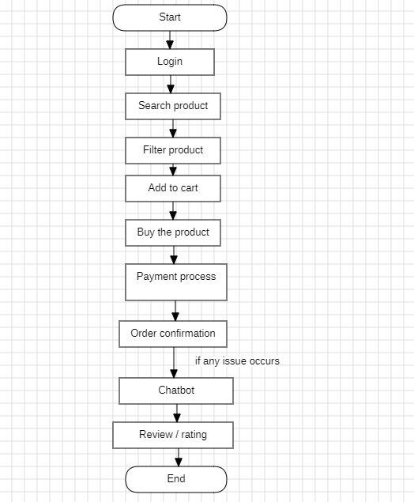

Figure 7:4.3.1.1 Logic diagram

4.3.2 DATA STRUCTURES
- Array Data Structures:
Array is the collection of elements with same or different data types. It exist of single as well as multiple dimensions.it came into an existence when we need to store multiple elements at one place. Each element in an array is uniquely identify with index numbers and the index number starts with zero.

- Queue Data Structures:
A Queue can be defined as an ordered list which enables insert operations to be performed at one end called REAR and delete operations to be performed at another end called FRONT. Queue is referred to be as First In First Out (FIFO).

- Graph Data Structures:
A Graph data structure is a collection of nodes that have data are connected to other nodes. It is a non-linear data structure consisting of vertices and edges. The graph is denoted by G(V,E).

- Stack Data Structures:
A Stack is a linear data structure that follows the LIFO (Last In Last Out) principle. Stack has only one end. Stack can be defined as a container in which insertion and deletion can be done from the one end known as the top of the stack. For insertion and deletion Stack uses push() and pop() operations.

- Linked List Data Structures:
A Linked list is a linear data structure that includes a series of connected nodes. Here each node stores the data and the address of the next node. The elements are not stored at a contiguous location, rather they are linked using pointers.

- Tree Data Structures:
A Tree is a non-linear hierarchical data structures that consist of nodes connected by edges. A Tree data structures is defined as a collection of objects or entities known as nodes that are linked to represent hierarchy. It doesn’t store in a sequential manner. It is a hierarchical structure as a element in a tree are arranged in multiple levels.

4.3.3 ALGORITHMS DESIGN:

Step1: Open an ecommerce website using your desired devices.
Step2: Login using your login credentials like (username, password) If the user is new to the website user has to sign-in an create the account.
Step3: User can search the product they want and can use the filter option to add the filters they required.
Step4: If they like the product then they will add to cart and move to the next process
Step5: Once they have added the product into cart they will further move to buy the product using suitable payment modes.
Step6: Once they have selected the payment mode the further payment process will start
Step7: As soon as the payment process is being completed the order will be placed and the order details would be available to the user on the website itself
Step8: If user encounters any issues related to the overall process of the website they can take the help of chatbot. It will address the queries of the users.
Step9: User can Step back from the website once the all process is done.

4.4 USER INTERFACE DESIGN

- Sign-in page:

When the user wants to login into the website he has to fill the details mention in the sign-in page.

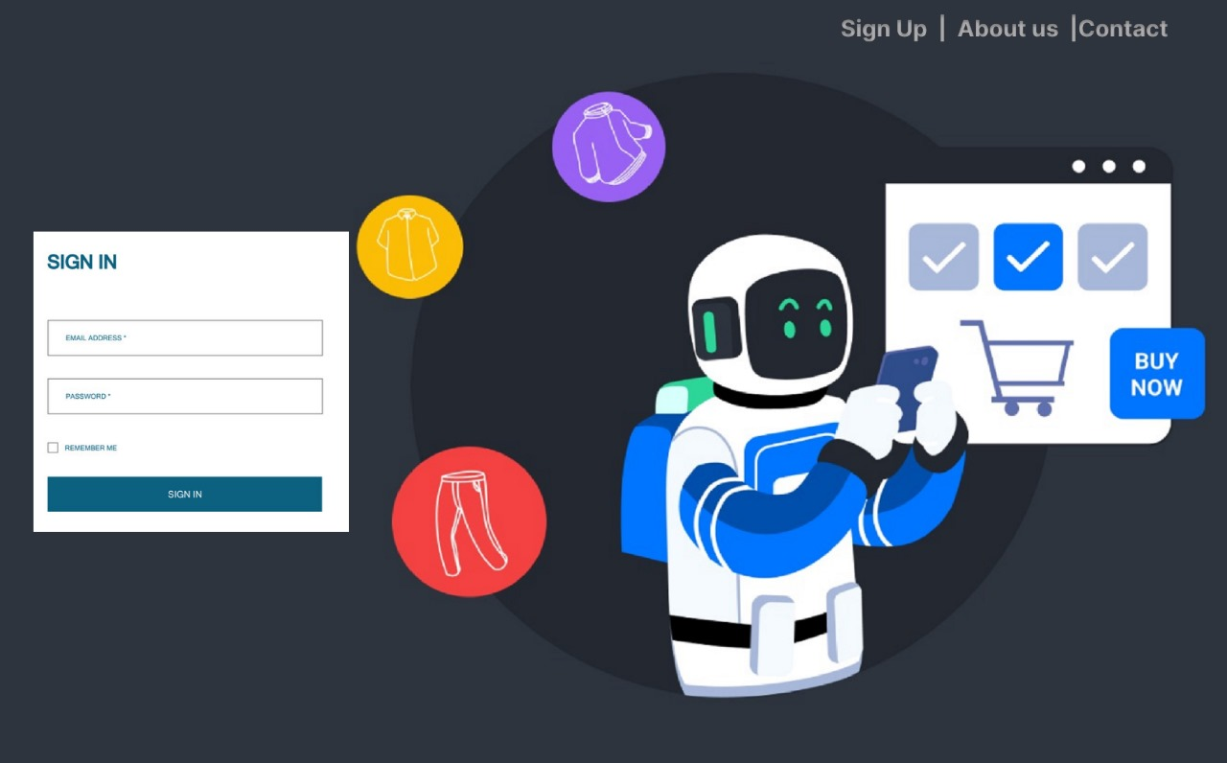
Figure 8:4.4.1 Sign-in Page

- Signup page:

When the user is new to the website and the person has to use the website then the person has to signup first by filling the details mentioned in the signup page.

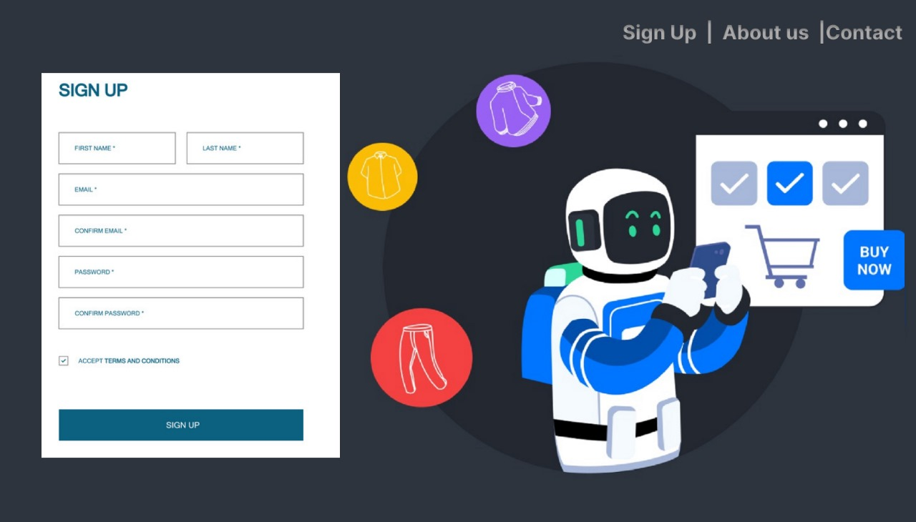

Figure 9:4.4.2 Signup Page

- Home Page:

As soon as the user login/signup a starting page would be serve the main page of the website after that user can proceed to buy the product as per their requirements.4ads



Figure 10:4.4.3 Home Page

- Chatbot:

When the user finds himself in trouble then with the help of chatbot they can find the solution within a second.

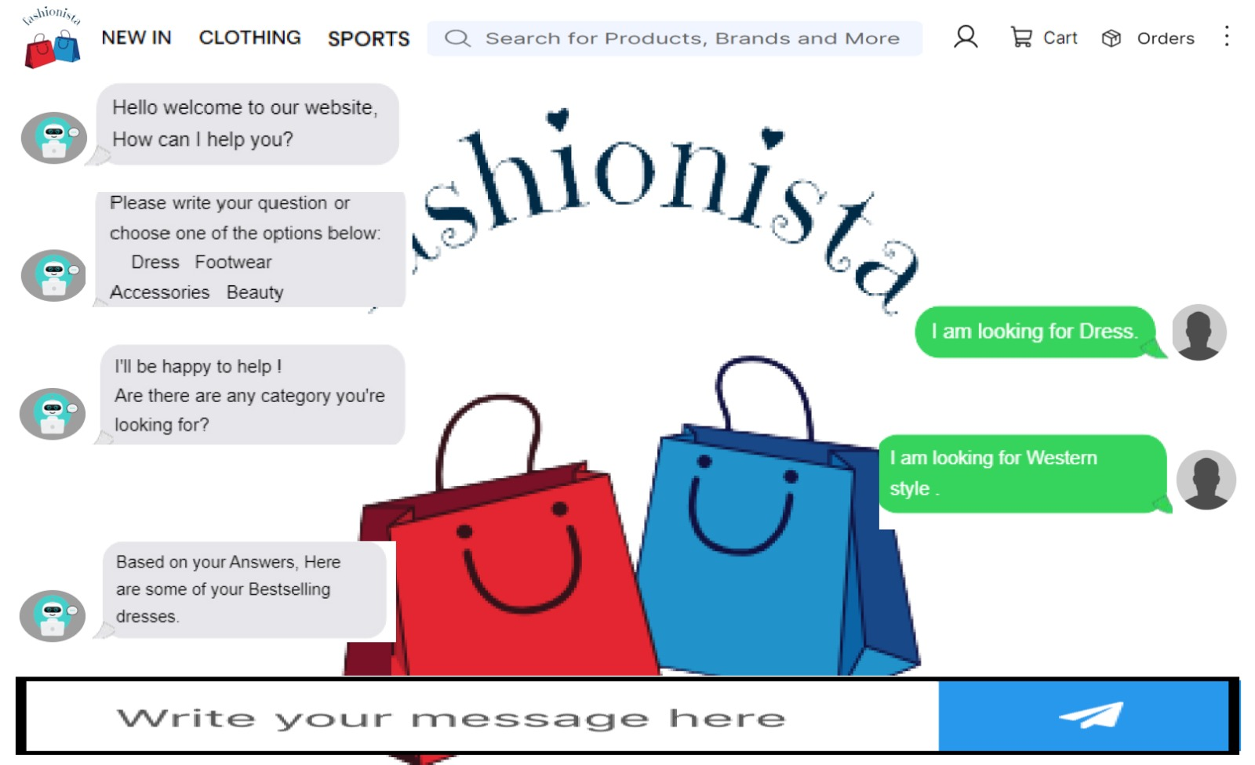

Figure 11:4.4.4 Chatbot

4.5 SECURITY ISSUES
Data privacy and protection:
- Customer data:
The data collected by the Chatbot is sensitive which includes personal details, payment details. Maintaining the confidentiality and integrity is a challenging job.
Authentication and Authorization:
- Access Control:
Chatbot should ensure that the accessibility of the data should only be with the authorized users and the access should be restricted based on roles and responsibilities.
- Authentication:
Strong authentication should be provided to prevent unauthorized access to chatbot administration and customer data.
Bot Verification:
- Bot Detection:
Chatbot should be able to distinguish between safe user interactions and malicious bot activities or fraud transactions.
Data Retention and Deletion:
- Data Lifecycle:
The clear data deletion policies to ensure that the customer’s data is not retained longer than necessary.

Updates:
- Software Updates:
The Chatbot Software should be up to date with security patches and updates.

4.5 TEST CASES DESIGN

- Admin Login:

Test Case ID | User Name | Password | Actual  Result | Result | Status
T1 | Abc_123 | Abc@123 | Login Successful
T2 | Abc_1234 | Abc@123 | Login Failed  Username Incorrect
T3 | Abc_123 | Abc$%1 | Login Failed  Password Incorrect
T4 | Abc_1234 | Abc$125 | Login Credentials  Incorrect
Table 15:4.5.1 Admin login

Test Case ID | User Name | Password | Actual  Result | Result | Status
T1 | Abc_123 | Abc@123 | Login Successful
T2 | Abc_1234 | Abc@123 | Login Failed  Username Incorrect
T3 | Abc_123 | Abc$%1 | Login Failed  Password Incorrect
T4 | Abc_1234 | Abc$125 | Login Credentials  Incorrect
- Sign Up:

Table 16:4.5.2 SignUp

- User login:

Test Cases | Username | Password | Actual Result | Result | Status
T1 | Abc_123 | Abc@123 | Login Successful
T2 | Abc_1234 | Abc@123 | Login Failed  Username Incorrect
T3 | Abc_123 | ABc@1212 | Login Failed Password Incorrect
T4 | Abcd_1223 | Abc$112 | Login credentials Incorrect
Table 17:4.5.3 User Login

